**Detailed dataset information sheet**

|  |  |
| --- | --- |
| **Information Objective** | International Pathways |
| **Data Products** | AA Ports of First Entry |
| **Information Source / Model Product** | [Department of Home Affairs: Ports of Entry](https://www.homeaffairs.gov.au/trav/ente/avia/maritime/ports-of-entry) |
| **Product Completion Progress** | Complete |
| **Dataset / Metadata Document** | Australian_Seaports_April_2018.shp  AA Ports of First Entry Metadata.pdf |
| **Dataset Use** | Surveillance Strategy and Design, Pathway Risk Analysis |

**Background**

A national point feature spatial dataset layer identifying the current Approved Arrangements ports of entry has been developed utilising the [Department of Home Affairs: Ports of Entry](https://www.homeaffairs.gov.au/trav/ente/avia/maritime/ports-of-entry) publicly available information and Google Earth, Google Maps and associated search engine resources.

**Initial Dataset Procurement Process**

The dataset has been derived by a number of manual processes:

* An initial search of the departments website was undertaken
* GPS coordinates from the department’s list were cross checked and visually confirmed within Google Maps and the features geocoded against the Current_Australian_Seaports_as_at_April_2018.xls excel spreadsheet
* A two kilometre circular buffer feature layer was created within ArcMap around the AA ports of entry which is then imported into Google Earth as a layer (Figure 1) for assistance in creating other datasets as described in their detailed product data sheets

Figure 1. Google Earth view of “community garden” search results and AA port of entry 2km buffer (orange circle)

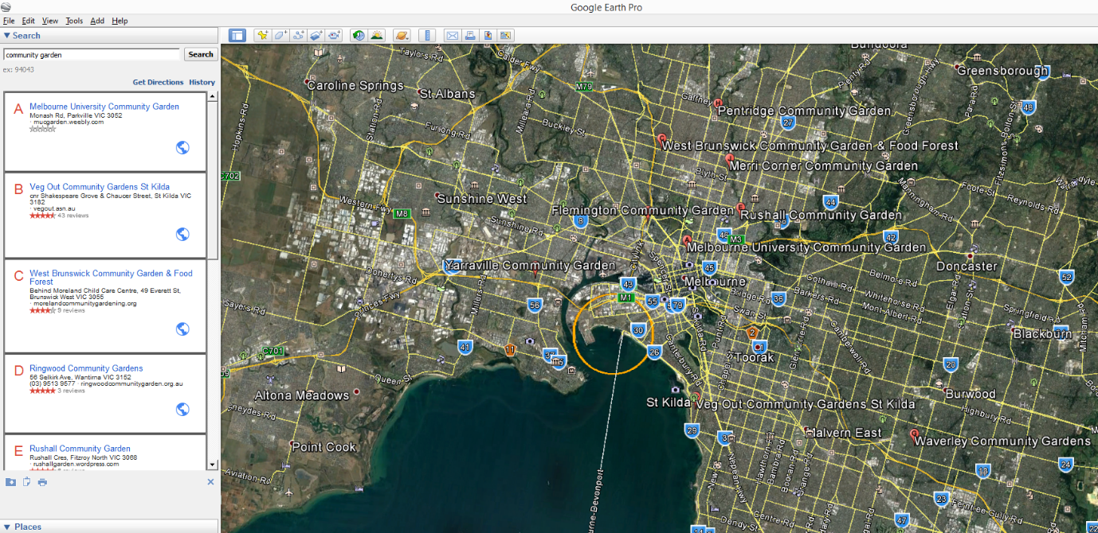

**In progress Dataset Procurement Processes**

No further data procurement is required for the initial stage as this dataset is complete.

Future work will require more detailed information on data procurement processes if this work is undertaken.

**Limitations**

* None considered at this stage of the data procurement

**Quality Check**

* The Department of Home Affairs port list was visually cross-checked within Google Earth and Maps for GPS coordinate accuracy

Table 1. Summary of the datasets and their completion status to date

|  |  |  |  |  |
| --- | --- | --- | --- | --- |
|  | **Initial feature Count** | **Additional features detected** | **Estimated number of features to be captured** | **Estimated total feature count of completed dataset** |
| **Australia** | **37** | **0** | **0** | **37** |

Discussion and Future Work

Periodic review of currency of Approved Arrangements ports as listed on the Department of Home Affairs website.

Mapping of the bulk commodity that is transferred through each site could be undertaken.

Major Ports of Origin to each AA port could also be mapped and attributes such as their climate zones and voyage distances to each Approved Arrangement Port calculated.

This could assist in improving future risk analysis projects such as those undertaken by the Risk-Return Resource Allocation unit and in more detailed risk analysis of entry potential for the National Priority Plant Pests (NPPP) project.

Project Resources Estimates and Uses

An estimate of the timeframes and data procurement requirements required to complete this dataset is summarised in Table 2.

The end result will be a dataset product which is of an Authoritative quality and can be referenced as a point of truth data source for input into projects such as surveillance strategy and design.

This dataset will provide accurate and useful information such as:

* Approved Arrangements port facility locations
* Ownership and Contact information (State or Private)
* Commodity material
* Voyage Distance from Ports of Origin to AA Port
* Climate Zone information of Ports of Origin
* Voyage Survivability index of NPPP pests deemed to be of high risk
* Risk ranking of AA Ports of Entry for NPPP pest incursions and likely source Port of Origin

And will assist in:

* Serving as an input in determining suitability of survey methods for pests such as those in the National Priority Plant Pests (NPPP) target groups, e.g.
* Mapping requirements for national/state emergency response programs that are deployed when these pest incursions occur as potential sites of first incursion and establishment
* Providing a feed-in data layer into the Pest Analysis tool created as part of the Biosecurity Plant Division Program BPD.3.S.01 Plant Health Surveillance Regulated Trade Pathways Risk Analysis Reports (Products 1.1.3-1.1.5) for improving the risk rating of sources jurisdictions trade distribution pathways
* Providing a feed-in data layer alongside the national road network for determining distribution pathways and the risk levels of these pathways

Table 2. Comparison of process methods and output dataset quality expectations

|  |  |  |  |  |
| --- | --- | --- | --- | --- |
| **Process** | **Requires Industry Assistance** | **Requires State Government Assistance** | **Estimated time to complete** | **Expected Dataset Quality Level** |
| Initial | No | No | Complete | Authoritative |
| Future | Possibly | Possibly | ~ 6-8 weeks | High to Authoritative |